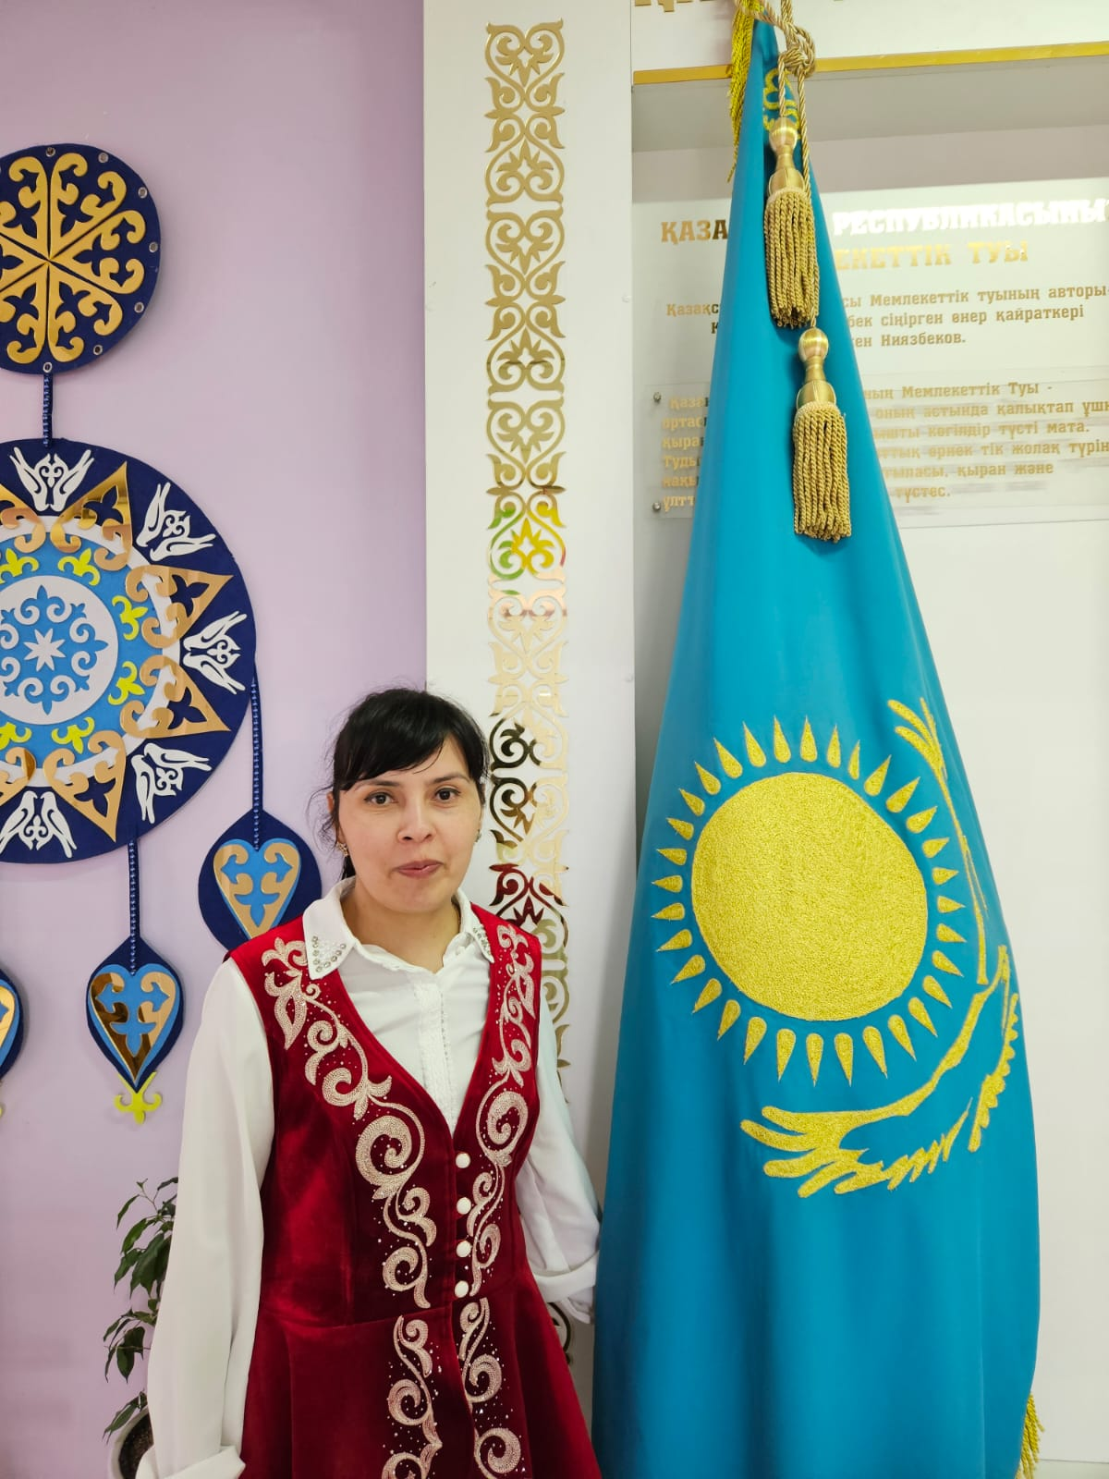

**КУЛАБДУЛЛАЕВА Мафтуна Бахадировна,**

**Сабыр Рақымов атындағы №53 жалпы орта білім беретін мектебінің ағылшын тілі пәні мұғалімі.**

**Шымкент қаласы**

**A BIOGRAPHY**

|  |  |  |  |  |  |  |
| --- | --- | --- | --- | --- | --- | --- |
| **Objectives according to the Curriculum** | | 8.4.6.1- recognize the attitude or opinion of the writer on a range of unfamiliar general and curricular topics;  8.5.3.1- write with moderate grammatical accuracy on a limited range of familiar general and curricular topics;  8.5.4.1- use with some support style and register appropriate to a limited variety of written genres on general and curricular topics;  8.5.7.1- use with minimal support appropriate layout at text level for a growing range of written genres on familiar general and curricular topics | | | | |
| **Objectives of the lesson** | | **All learners will be able to:**  **Most learners will be able to:**  • read a biography of the pop group ABBA.  • learn about the use of sequencers and connectors.  • write a biography of an artist or band from the past.  **Some learners will be able to:** | | | | |
| **Evaluation criteria** | | Identify the attitude and opinion of the author  Express their opinion about the visited events  Use grammatical structures in the sentences correctly | | | | |
| **Level of thinking skills** | | Low order thinking | | | | |
| **During the lesson:** | | | | | | |
| **The stage of the lesson/timing** | **Actions of the teacher:** | | **Actions of the pupils:** | **Student actions with special educational needs** | **Assessment** | **Resources** |
| **The beginning of the lesson/**  **min** | Greetings (1 min)  The teacher greets students; students respond to greeting and take their places.  Hello, boys and girls! How are you?  Students must answer the questions:  Students must divide in two groups: The groups name is Actors and Singers.  Warm up (1 min)  Video “What is this biography?”  Ask students if they know of any English- bands famous people or artists. • If students cannot name any, introduce them to some examples e.g. The Beach boys, Jenifer Lopez, Hudson, Enrique Iglesias. | | students respond to greeting and take their places.  Students must divide in two groups. The groups name is Actors and Singers  Student must watch a video about biography.  . The Beach boys, Jenifer Lopez, Hudson, Enrique Iglesias. | students respond to greeting and take their places.  Students must answer the questions: |  |  |
| **The middle of the lesson**  **35 min** | Reading (5 min)  1 • Ask students to open their books at page 39.  • Refer students to the photo and ask them the questions.  • Students then read the biography to check their answers.  2 • Refer students to the fact file.  • Put students into pairs and ask them to read the text again and complete the facts about ABBA.  • Check answers.  New words:  Biography- биография  Popular-машхур  Successful-омадли  Famous-таникли  Records-езувлар  Split up-булиниш  Song-кушик  Single-ягона  Work with posters: with ex:2  Practice  Sing a song with students Abbas Happy new year  Grammar  4 • Read out the information about sequencers and connectors in the Useful language box.  • Explain that words and phrases such as although and as a result are used to make a piece of writing coherent. Drill the pronunciation of although /ɔːlˈðəʊ/.  • Ask students to work alone to find three further examples of such words and phrases in the biography in Exercise 1.  • Check answers. You could then elicit further example sentences using these words and phrases as a means of checking students’ understanding. If you do this, write the example sentences on the board and ask students to copy them into their notebooks.  Groups work  Put students into pairs and ask them to complete the  sentences about ABBA using the words and phrases in the box.  • Check answers.  • If students do not know ABBA’s music, you could  introduce them to some of the band’s songs on  YouTube. They could listen to the songs referred to in the biography or the band’s performance of Waterloo at the Eurovision Song Contest in 1974.  • You would probably be advised to do this as a whole class activity. Otherwise the class may become a cacophony of competing songs.  Get writing  PLAN  6 • Students should do their planning in class. The writing can either be done in class or at home.  • Tell students they are going to write a biography of a band or artist from the past.  • You may want to brainstorm some bands or artists with the class as a whole to give the class some ideas.  • Refer students back to the headings in Exercise 2 and then ask them to work alone to make notes. If you choose to do the writing in class, encourage students to use their smartphones to look up information online.  WRITE  7 • Tell students to use the biography of ABBA as a model to follow.  • Give students ten minutes to complete the writing task. Students should write between 140 and 160 words.  • Monitor while students are writing. Help with grammar and vocabulary as necessary.  CHECK  8 • Tell students that it is very important that they check their writing in order to look for ways to improve its content, style and structure.  • Give students a few minutes to look through their biographies and check them against the points here.  • Collect students’ texts and mark them. | | Students read the bibliography and answer the questions  • Refer students to the fact file.  Students must work with posters  Students sing a song “Happy new year”  Students sing a song “Happy new year”  Students must learn by hard the new words.  Work with posters.  Students work on grammar and complete the tasks  Students work in pairs and complete the sentences  Students follow the plan and instructions and complete writing task | Students read the bibliography and answer the questions  Students sing a song “Happy new year”  Students work in pairs and complete the sentences  Students follow the plan and instructions and complete writing task | 1 Point for each correct answer  1 point for each correct answer  Teacher guides and evaluates students  1 point for each correct answer  Teacher guides and evaluates students | Book, slide  Book, slide  Book, audio, slide  Book, slide  Book, slide |
| **The end of the lesson**  **5 min** | Homework (5 min)  Set Exercises 1, 2, 3 and 4 on page 28 and  Exercises 5, 6, 7, 8, 9, 10 and 11 on page 29  of the Workbook for homework. | |  |  |  |  |